**Case Study Assignment: Todo List Spring Boot Application with Amazon DynamoDB**

Step 1 : Create a spring boot application.

Step 2 : Create a dynamoDB table

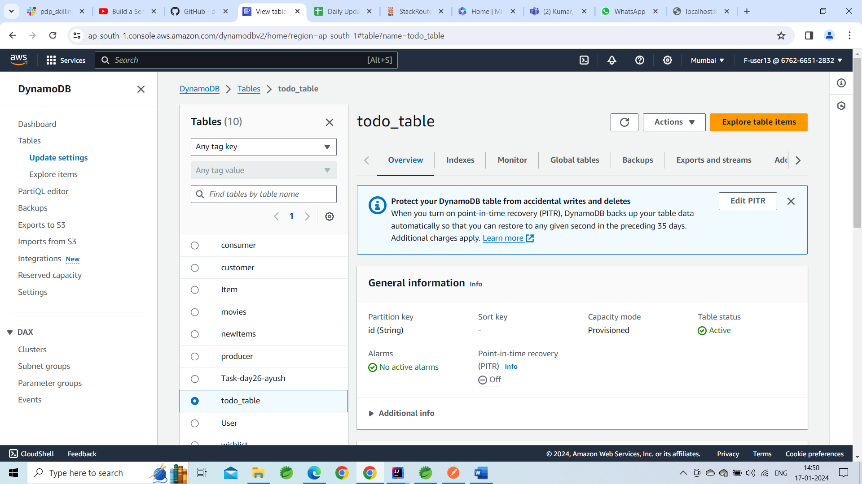

Step 3 : Configure the properties in the application.properties file.

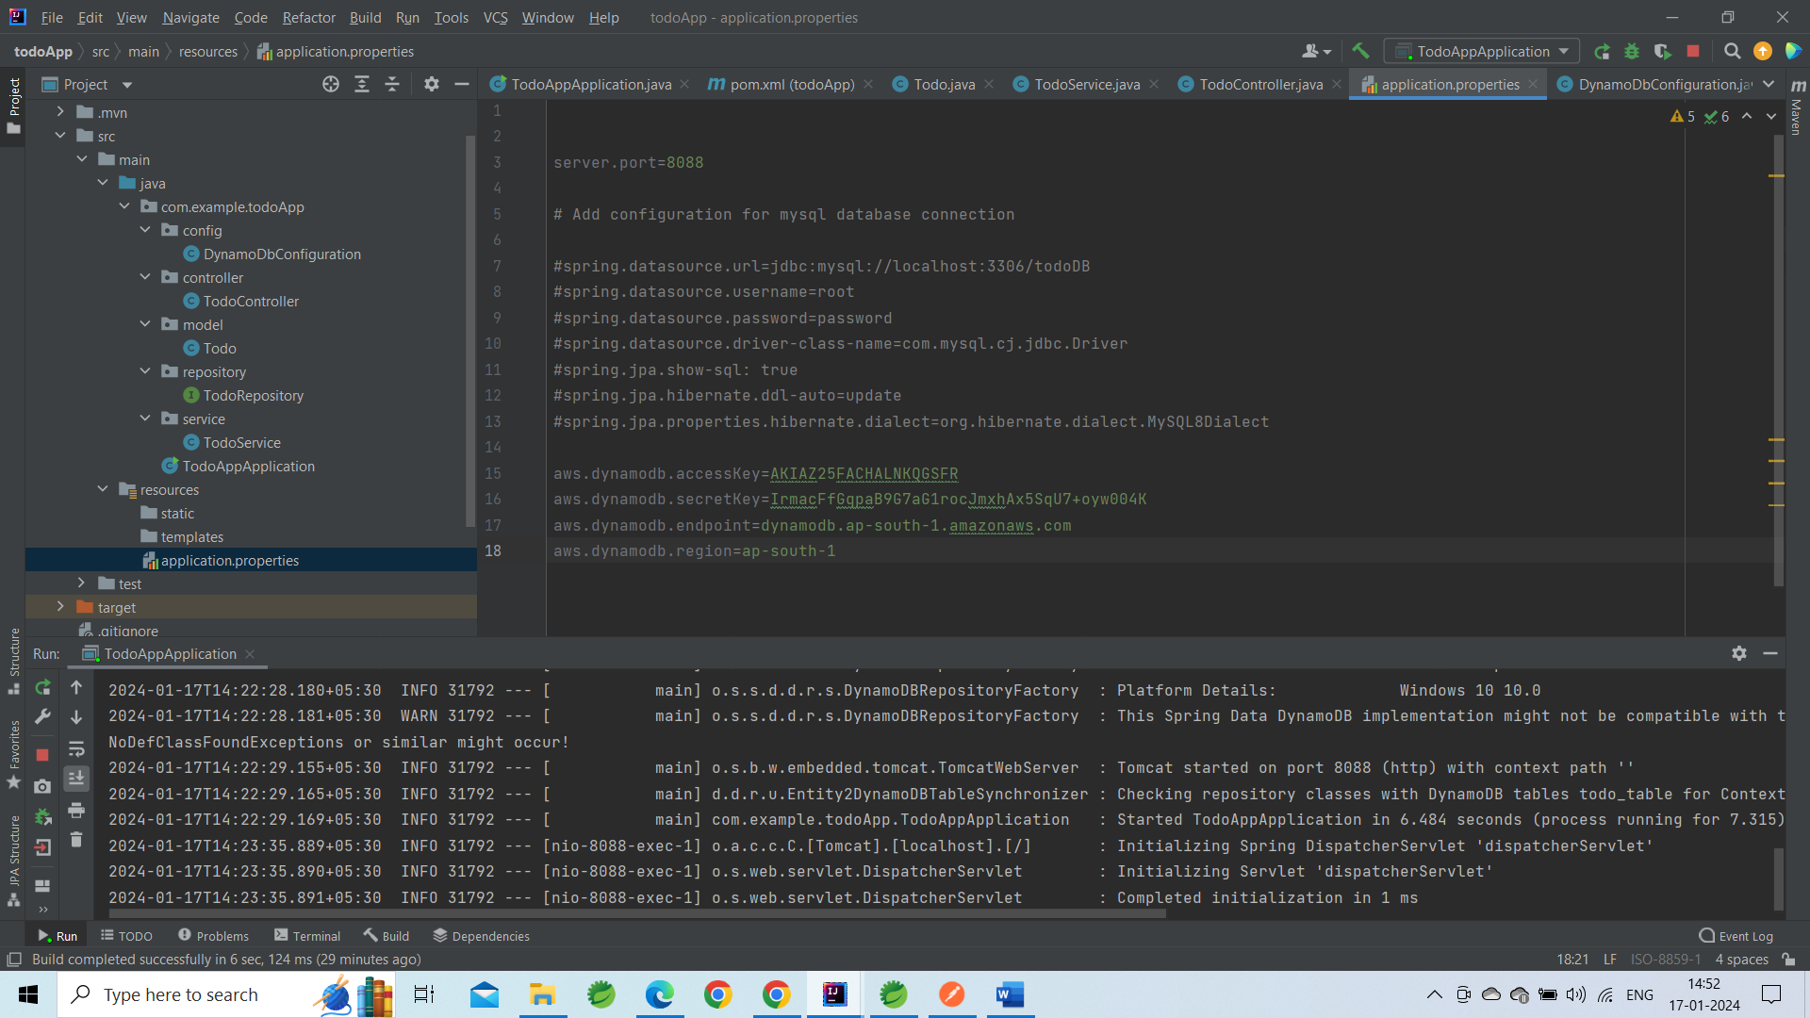

Step 4 : Start your application and hit the enpoints in postman.

Adding task3 to the table.

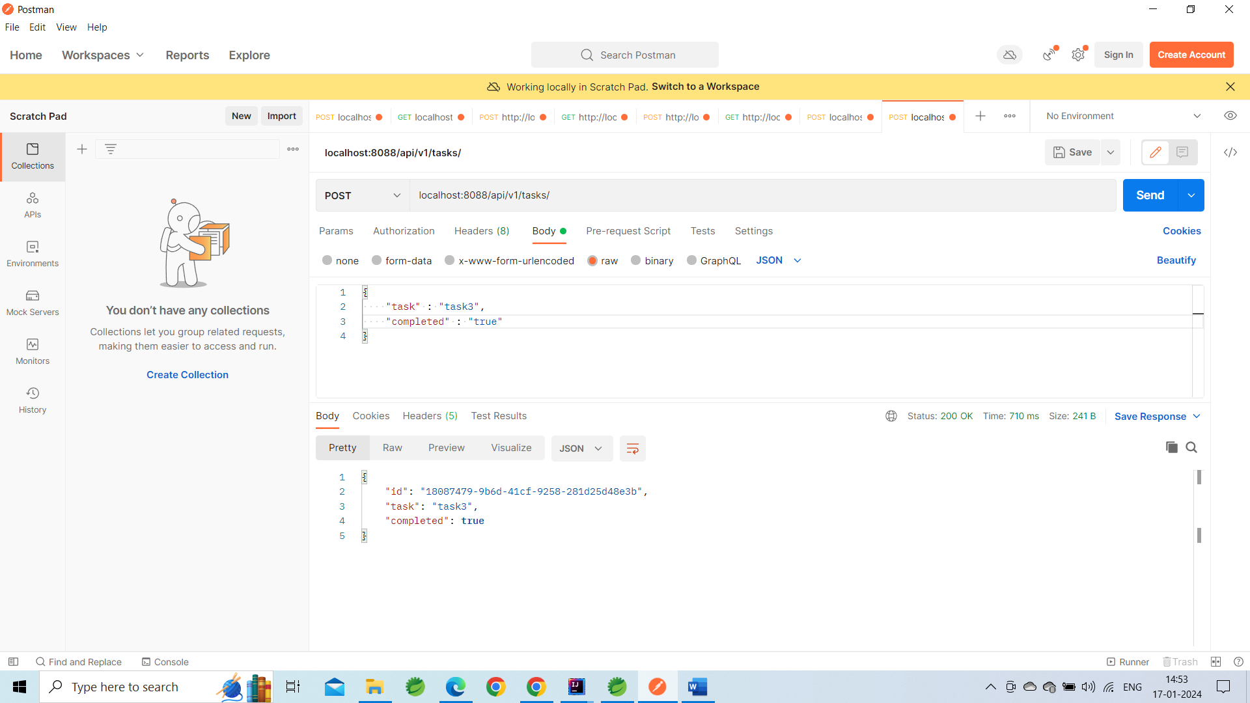

Step 5 : Check the table in the dynamoDb if the data is added or not.

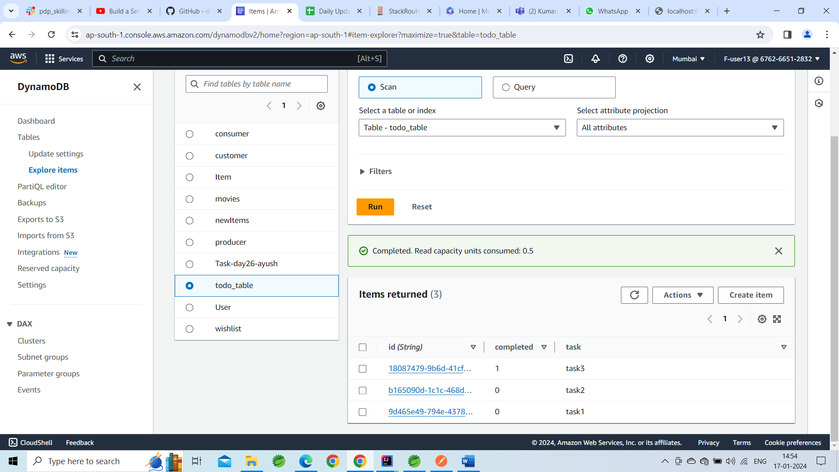

We can see that task3 is added here.

Step 6 : Hit other endpoints such as try deleting the task3 from postman.

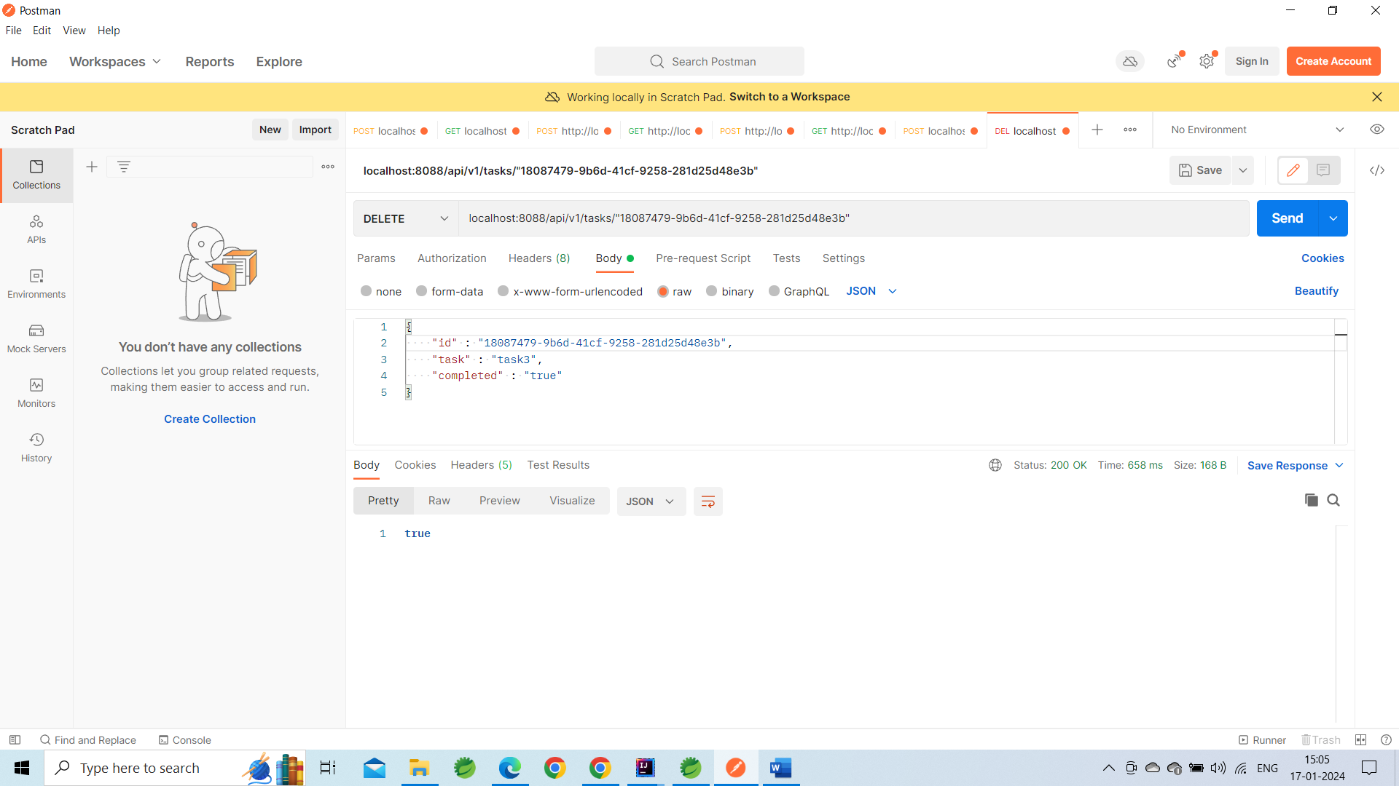

Step 7 : Check in dynamodb table if the task3 is deleted or not.

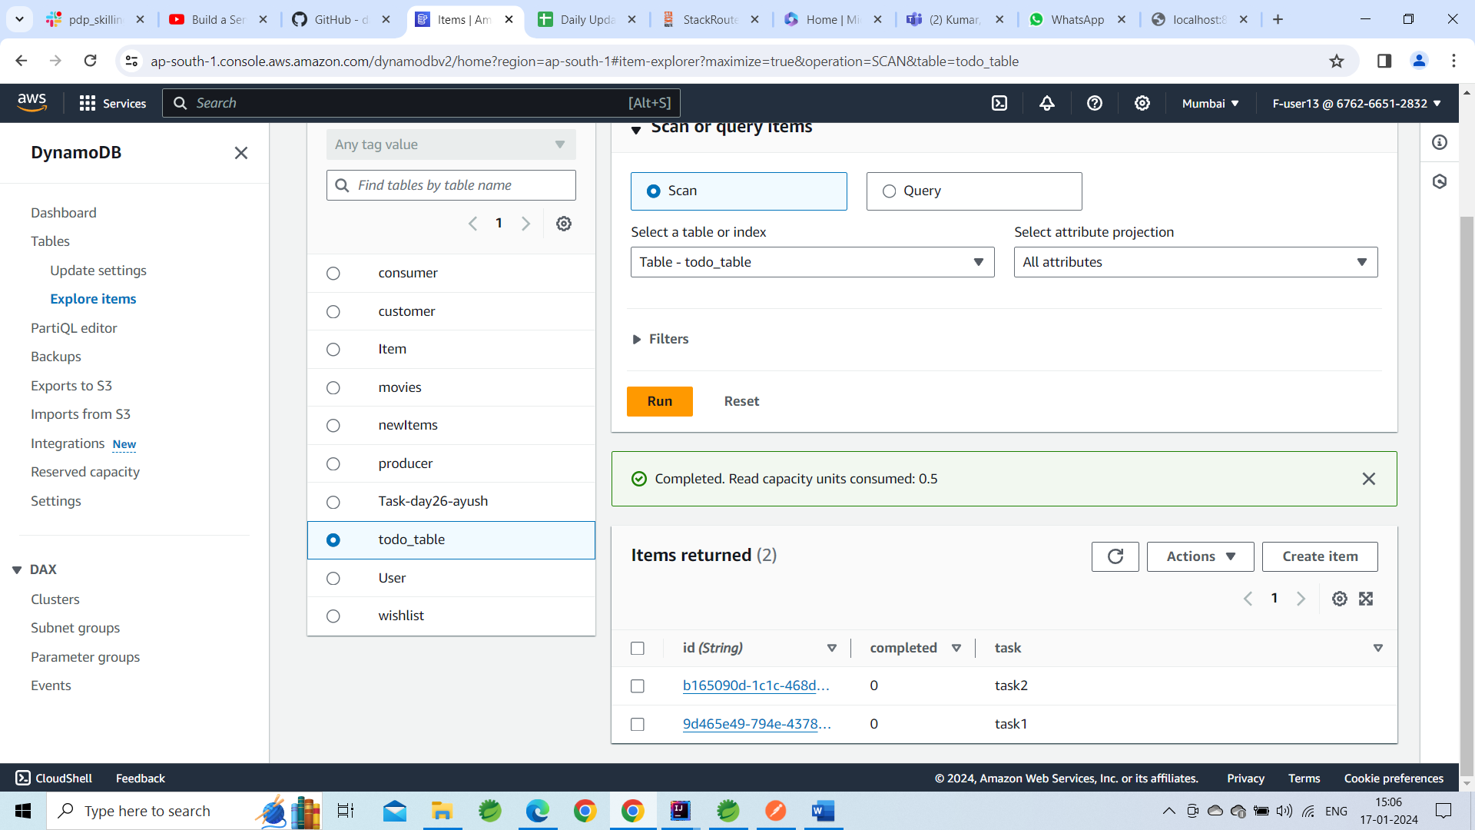

Here we can see that task3 is deleted.